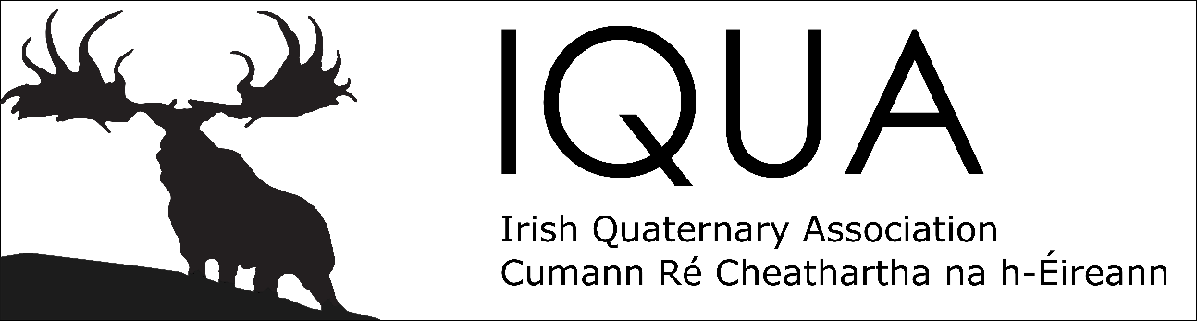

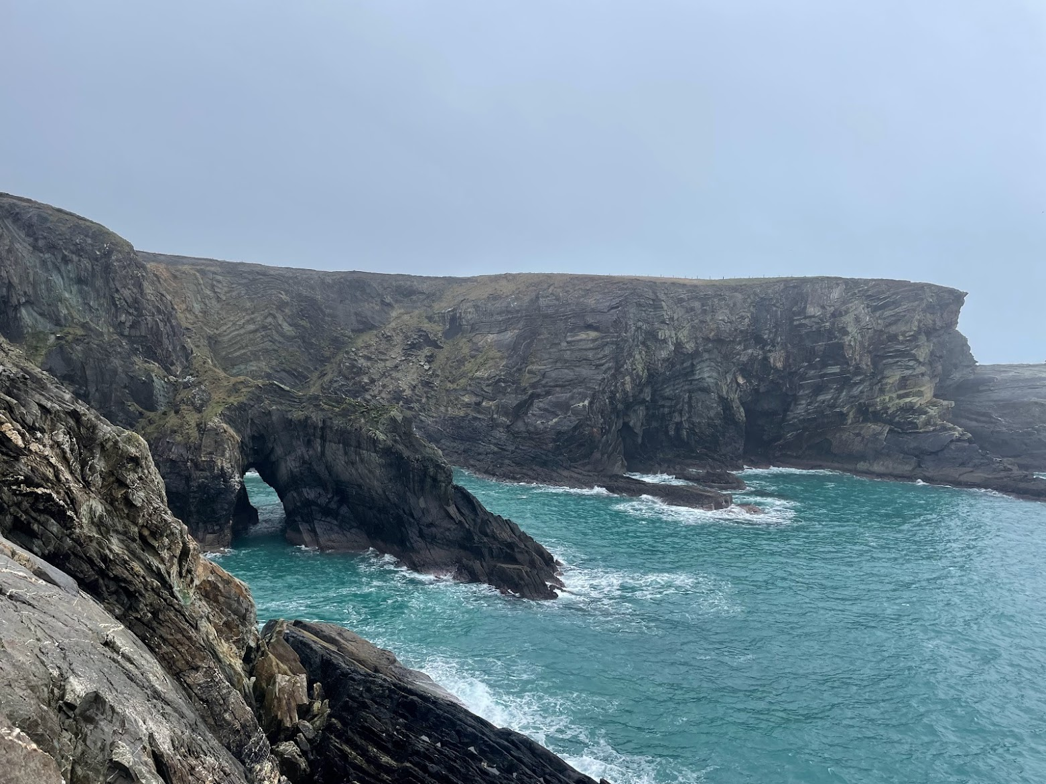

Spring Meeting and AGM 2023
25th March 2023

Programme and Abstracts

Cork Enterprise Centre,
School of Biological, Earth and Environmental Sciences,
University College Cork

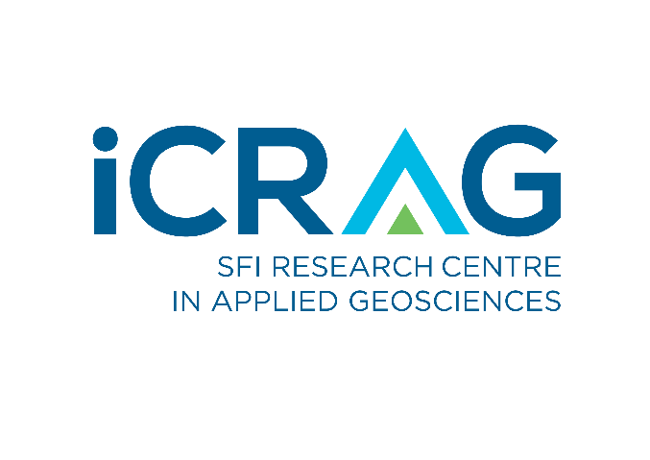

Programme

9:00 Registration opens

9:30 Welcome address

9:40 Keynote talk
Eileen McCarthy (QMEC Environmental and UCC)

Session 1: Peatland monitoring and restoration
Session chair: Michelle McKeown

10:00 Callum Evans
Response of testate amoeba communities to peatland drain blocking
10:15 Dave O’Leary, J. Connolly, L. Gilet, J. Hodgson and E. Daly
Using Tellus Airborne Radiometric data to update the national peatland map in Ireland
10:30 Rebecca Rivera, F.J.G. Mitchell, M. Saunders and C.J. Harper
Fungi and other microorganisms as indicators of peatland response to climate change, health, and restoration

10:45 Tea/coffee

Session 2: Geochronology and geomorphology
Session chair: Kieran Hickey

11:15 Sam Kelley, A. Doughty, M. Butler, M. Moucheron and G. Warren
Looking Up: A multidisciplinary project on glacial geology and early prehistoric heritage in the Cairngorm Mountains
11:30 Jack Mason, R. McNabb, P. Dunlop and B. Davies
A geomorphological investigation into glacier change since the Little Ice Age (LIA) in the Brooks Range, Alaska, USA
11:45 Luke O’Reilly, R. Fentimen, F. Butschek, J. Titschack, A. Lim, N. Moore, O.J. O’Connor, J. Appah, K. Harris, T. Vennemann, A.J. Wheeler
Environmental forcing by submarine canyons: Evidence between two closely situated cold-water coral mounds (Porcupine Bank Canyon and Western Porcupine Bank, NE Atlantic)

Official sponsor
Session 3: Long-term relationships between climate, landscape, and humans Session chair: Ben Gearey

12:00 Helen Essell, G. Plunkett
A palaeoenvironmental perspective on transhumance in the Mourne Mountains, Northern Ireland
12:15 Kangkang Li, X. Qin, G. Plunkett
The Bronze Age population in eastern Tarim Basin (Lop Nur), northwest China, and their subsistence environment
12:30 Louise Smith, J, Oliver, G. Plunkett and K. Britton
Investigating the long-term effects of agriculture on biodiversity in the uplands of Scotland
12:45 Sarah Ferrandin, G. Plunkett, K. Britton, N. Ogle
Land-use and climate changes during the Irish Bronze Age: what can the nitrogen cycle tell us?

13:00 Lunch

14:15 Panel Discussion: Academia and industry
Panellists: Dr Aaron Lim (University College Cork), Ms Eileen McCarthy (QMEC Environmental) and Dr Margaret Browne (Geological Survey of Ireland)

15:00 Tea/coffee

15:30 IQUA Prize-giving
15:40 Concluding remarks

15:45 AGM

Posters
Alex Clarke, S. Roberson, S.P.E. Blockley, A.P. Palmer, M. Damaschke and B.J. Davies
High-resolution glacial geomorphology of the Antrim Plateau, northeast Ireland

Susanth Sundaran, Riccardo Arosio, Andrew Wheeler, Martin Stokes and Ian Selby
Quaternary geology of the Celtic Sea Shelf: key understandings for offshore windfarm development in Ireland and UK

Julie O’Donovan, C. Chique, J. O’Dwyer, M. M. McKeown, A. Potito.
Temporal Assessment of Antimicrobial Resistance in the Environment (TARE)

Rebecca Rivera, F.J.G. Mitchell, M. Saunders and C.J. Harper
Fungi and other microorganisms as indicators of peatland response to climate change, health, and restoration

Keynote Talk: What has a Quaternary Qualification ever done for you? Insights from a 25 Years in Geo-Consultancy.

Eileen McCarthy^{1,2}

¹ QMEC Environmental, Cork, Ireland
² School of Biological, Earth & Environmental Sciences / Environmental Research Institute, Distillery Fields, North Mall Campus, University College Cork (UCC), Cork, Ireland
³ Irish Centre for Research in Applied Geosciences - iCRAG / SFI Research Centre for Energy, Climate and Marine - MaREI, University College Cork, Cork, Ireland

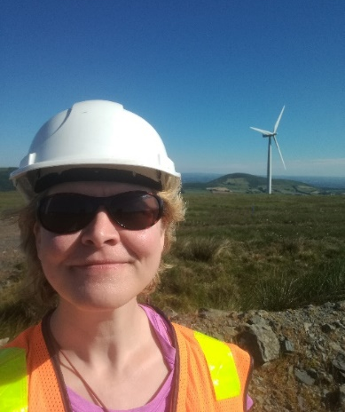
Biography
Eileen is a director and company owner for >25 years and runs QMEC Environmental, a consultancy that specialises in peatland hydrogeology and in peat landslide hazard and risk assessment. In the last 10 years, she has been a part time lecturer in University College Cork; she contributed to the design and set up of a new MSc programme in Applied Environmental Geoscience in UCC; and has been conducting iCRAG research in upland blanket bog hydrogeology and its significance for peat slope stability. Through this research, Eileen is working towards a doctorate. She has an MSc in Hydrogeology (University College London, 2001) and a BSc in Earth Science (University College Cork, 1998).

Response of testate amoeba communities to peatland drain blocking

Callum Evans¹*

¹Geography, School of Natural and Built Environment, Queen’s University Belfast, Belfast, Northern Ireland

*Corresponding author: cevans12@qub.ac.uk

Peatlands are increasingly important habitats due to their sizeable carbon stores. However, anthropogenic activity leave peatlands with a substantial management challenge. Degradation of peatland habitats through land-use change is often restored by re-wetting. Research into how this management affects peatland microbial communities is limited. Testate amoebae (single-celled protists) are commonly used for palaeohydrological reconstruction from peatlands – here we use these organisms as contemporary bioindicators of restoration success on three small raised bogs in the UK (Cranny Bogs, Northern Ireland). Two treatments (dammed and control) presented complex but meaningful results following management intervention. Though complicated, results imply wetter conditions following restoration, where routine monitoring was unable to suggest a trend this early after restoration. Following management: diversity increased generally across both treatments; unambiguous wet indicator taxa (e.g., Archerella flavum) were observed in increasing abundance at dammed treatment sites; and reconstructed water-table depths showed wetter conditions in dammed treatment sites. However, antecedent conditions obscured multivariate analysis leading us to reveal no significant community-level response to variables before, immediately following, or many months after restoration. Nevertheless, this study emphasizes the potential of an indicator-taxa based approach to applying testate amoebae as contemporary bioindicators of peatland restoration – particularly on short-term timescales immediately following restoration.

Using Tellus Airborne Radiometric data to update the national peatland map in Ireland

Dave O’Leary¹*, J. Connolly², L. Gilet², J. Hodgson³ and E. Daly¹

¹HYRES Research Group, Earth and Ocean Sciences and Ryan Institute, College of Science and Engineering, University of Galway, Galway, Ireland
²Department of Geography, Trinity College, Dublin, Ireland
³Geological Survey, Ireland (GSI), Booterstown, Blackrock, Co. Dublin, Ireland

*Corresponding author: d.oleary1@nuigalway.ie

Peatlands are important carbon holding habitats. Drained peatlands emit carbon via decomposition of stored material. National climate plans require knowledge of peatland spatial distribution nationally.

Peatland maps are created in many ways including optical satellite remote sensing or traditional mapping techniques. However, remote sensing cannot detect peatlands under landcover such as forest or grassland. Traditional maps are often created from sparse in-situ data which do not allow for accurate measurement of peatland boundaries.

Radiometrics, which measures environmental radiation, is suited to peatland studies. Modelling of radiometric attenuation shows a statistical difference in data recorded over peat, compared to a non-peat soil. Mineral soils contain geological material which acts as a source of radiation and peat is generally not considered a source of radiation. Peat tends to be saturated and water acts to attenuate the radiation also. These effects combined means that peatlands appear as a “low” radiometric signal in the landscape.

The Tellus survey (GSI) aims to acquire airborne radiometric data nationally in Ireland. This study uses these data combined with machine learning classification, to identify peatlands under modified landcover and update peatland maps. The results may update national and international inventories of peatlands area and inform European policy.

Fungi and other microorganisms as indicators of peatland response to climate change, health, and restoration

Rebecca J. Rivera¹*, Fraser J.G. Mitchell¹, Mathew Saunders¹ and Carla J. Harper¹

¹Botany Department, School of Natural Sciences, Trinity College Dublin, Dublin 2, Ireland

*Corresponding author: riverar@tcd.ie

Peatlands are culturally, economically, and ecologically important ecosystems in Ireland. The extraction and draining of Ireland’s peatlands over several centuries have negatively impacted peat biodiversity, in particular, the microorganisms. Climate change has led to a need for policies and new practices focusing on the protection and restoration peatlands. Reliable proxies to measure the effect and/or progress of peatland restoration are complicated and difficult to establish, especially without a comparable ‘baseline’ of microbial biodiversity. Fungi have been shown to be essential to peatland health; they are fundamental to biodiversity, carbon cycle dynamics and decomposition. Irish Quaternary peat deposits have yielded a wealth of information to palynology studies of peatland ecosystems; however, these studies are primarily based on pollen analyses. Non-pollen palynomorphs (NPPs) have been shown to be useful proxies as palaeoecological indicators and may prove to be a powerful tool that provide additional insights into palaeoecological studies. This research examines the diversity of NPPs, with a primary focus on fungi, of Quaternary peat deposits with aims to establish a baseline of microbial biodiversity, as well as target microbial restoration communities. NPP data analysis can help reconstruct environmental changes over time, which is fundamental to the maintenance and restoration efforts of peatlands.

Looking Up: A multidisciplinary project on glacial geology and early prehistoric heritage in the Cairngorm Mountains

Sam Kelley¹*, Alice Doughty², Micheál Butler³, Martin Moucheron³ and Graeme Warren³

¹School of Earth Science, University College Dublin, Dublin, Ireland
² School of Earth and Climate Science, University of Maine, USA
³ School of Archaeology, University College Dublin, Dublin, Ireland

*Corresponding author: sam.kelley@ucd.ie

Uplands are rapidly changing areas of the European landscape. Landscape and environmental change in highland regions is driven by a host of anthropogenic forces, such as reforestation/rewilding, tourism, and human-induced climate change. Accelerated landscape and environmental change have direct effects on natural and cultural heritage found in upland areas, resulting in poorly understood consequences. This lack of understanding stems from a gap in knowledge regarding the location and extent of cultural heritage in highland areas.

The Looking Up project utilizes glacial geology, Quaternary geochronology, and archaeology to generate predictive models of cultural heritage linked to early Holocene hunter-gatherer use of the Cairngorm region, the highest upland area in Brittan and Ireland. Our models assess the potential of cultural heritage across a highland landscape, a potential tool for landscape management. Here, I will present the progress to date on the Quaternary geologic side of this project, which explores the timing and style of deglaciation of the Cairngorm plateau and adjoining corries. Additionally, I will highlight the role that Quaternary geologic data plays in this multidisciplinary project.

A geomorphological investigation into glacier change since the Little Ice Age (LIA) in the Brooks Range, Alaska, USA

Jack Mason¹*, Robert McNabb¹, Paul Dunlop¹ and Bethan Davies²

¹School of Environmental Sciences, Ulster University, Coleraine, Northern Ireland
²School of Geography, Politics and Sociology, Newcastle University, Newcastle-Upon-Tyne, Tyne and Wear, England

*Corresponding author: mason-J3@ulster.ac.uk

Global and regional estimates of glacier mass and area change in high latitude areas are poorly constrained prior to 2000 due to a lack of data. This impedes our ability to comprehend and contextualise observed glacier mass loss, particularly when investigating changing rates of mass loss. This can be resolved by extending the glacial record back in time, to improve understanding of how glaciers have changed in high latitude regions under a longer-term time series of climatic change.

The Brooks Range, Alaska is a dry, high latitude region in the Arctic that has been understudied in the past. The glaciers are all land-terminating, making them good proxies to investigate the impact of climate change in the region.

This study aims to reconstruct glacier behaviour since the “Little Ice Age” (LIA) by reconstructing the Brooks Range LIA glacial maximum and comparing it to various points in time between then and 2022. We use mapped glacial features to infer LIA glacier outlines and calculate their approximate area and ELA. In some areas, glacier outlines digitised from topographic maps are available and were used as timestamps to correlate glacial features with their approximate age and evaluate changing rates of glacier wastage between LIA inferred outlines and 2022 outlines. We derive 2022 glacier outlines from Sentinel-2 imagery, using a band ratio method to automatically identify glaciers followed by vectorisation and manual editing to produce a Brooks Range glacier database. Generation of these outlines enables quantification of glacier area change and ELA change from the LIA to 2022.

Our new geomorphic maps will allow us to constrain rates of change and analyse how Brooks Range glaciers are responding to changing climatic forcings in the region. This will enable insights into the style and manner of the neoglaciation and deglaciation in the Brooks Range.

Environmental forcing by submarine canyons: evidence between two closely situated cold-water coral mounds (Porcupine Bank Canyon and Western Porcupine Bank, NE Atlantic)

Luke O’Reilly^{1,2}*, Robin Fentimen³, Felix Butschek², Jürgen Titschack^{4,5}, Aaron Lim^{1,6}, Niamh Moore^{7,8}, O.J. O’Connor^{7,8}, John Appah¹, Kimberley Harris⁹, Torsten Vennemann¹⁰ and Andrew J. Wheeler^{1,11}

¹School of Biological, Earth & Environmental Sciences / Environmental Research Institute, Distillery Fields, North Mall Campus, University College Cork (UCC), Cork, Ireland
²Green Rebel, Green Rebel, Penrose One, Penrose Dock, Cork, Ireland
³ENS Lyon (Dept of Earth Sciences, Ecole Normale Superieure de Lyon, 46 allée d'Italie, Lyon, France
⁴MARUM – Center for Marine Environmental Sciences, University of Bremen, Bremen, Germany
⁵Senckenberg am Meer, Marine Research Department, Wilhelmshaven, Germany
⁶School of the Human Environment, University College Cork, Cork, Ireland
⁷Department of Radiology, Cork University Hospital (CUH), Wilton, Cork, Ireland
⁸Department of Radiology, University College Cork, Cork, Ireland
⁹DP Energy Ireland Ltd, Mill House, Buttevant, Co. Cork, Ireland
¹⁰IDYST – Institute of Earth Surface Dynamics, University of Lausanne, Lausanne, Switzerland
¹¹Irish Centre for Research in Applied Geosciences - iCRAG / SFI Research Centre for Energy, Climate and Marine - MaREI, University College Cork, Cork, Ireland

*Corresponding author: luke.oreilly@greenrebel.ie

Cold-water coral (CWC) mounds within the Porcupine Bank Canyon in the NE Atlantic are mostly clustered along the canyon lip, with individual disconnected mounds nearby on the western Porcupine Bank. This study utilizes a novel method of remotely operated vehicle-mounted vibrocoring to acquire cores from both sites, enabling precise sampling of the closely situated areas. Radiometric ages constrain the records from the early to mid-Holocene (9.1 to 5.6 ka BP), and 3D segmented computer tomography was used to capture mound formation stages. The cores were further examined using stable isotopes and benthic foraminiferal assemblages to understand the paleoenvironmental variation that influenced CWC mound formation. Results show that regional climatic shifts define the environmental conditions that allow positive coral mound formation. Coral mound aggradation rate was comparable to other Holocene CWC mounds off western Ireland, and the aggradation rate was higher adjacent to the Porcupine Bank Canyon than on the western Porcupine Bank. The study hypothesizes that coral mound formation in the region is likely controlled by an interplay between enhanced shelf currents and the existence of the Eastern North Atlantic Water-Mediterranean Outflow Water-Transition Zone. The geomorphology of the canyon promotes upwelling of these water masses that are enriched in particles, including food and sediment supply. These observations highlight the role that submarine canyons play in influencing macro and micro benthic fauna distributions and emphasize the importance of their conservation.

A palaeoenvironmental perspective on transhumance in the Mourne Mountains, Northern Ireland

Helen Essell¹*, Gill Plunkett¹

¹Archaeology & Palaeoecology, School of Natural and Built Environment, Queen’s University Belfast, Belfast, Northern Ireland

*Corresponding author: hessell01@qub.ac.uk

Uplands are widely perceived as marginal within the landscape. This is not solely due to their geographical isolation; upland environments are highly susceptible to the negative effects associated with periods of climatic deterioration. A rich archaeological record and historical evidence, however, attest to human presence in uplands through the past. In the Medieval and early post-Medieval periods, uplands are thought to have provided space for transhumance, a practice involving the seasonal movement of people and livestock to higher ground to exploit land for grazing in the summer months. The precise nature of activity and chronology of occupation at associated booley huts is poorly understood. Here, we explore transhumance in the context of the Mourne Mountains, Northern Ireland. Through palynological analysis of blanket peat sequences extracted from the vicinity of booley huts, this study explores how settlers shaped and interacted with their environment. We identify Later Medieval to Early Modern settlement at two sites characterised by grazing concurrent with cereal cultivation, challenging narratives of transhumance simply being associated with herding. These findings provide insights into human-environment interactions in ‘marginal’ upland landscapes, informing adaptation strategies for present and future populations who face environmental pressures similar to those of societies in the past.

The Bronze Age population in eastern Tarim Basin (Lop Nur), northwest China, and their subsistence environment

Kangkang Li^{1,2}*, Xiaoguang Qin¹ and Gill Plunkett²

¹Key Laboratory of Cenozoic Geology and Environment, Institute of Geology and Geophysics, Chinese Academy of Sciences, Beijing, China
²Archaeology and Palaeoecology, School of Natural and Built Environment, Queen’s University Belfast, Belfast, Northern Ireland

*Corresponding author: k.li@qub.ac.uk

The Bronze Age of the extremely arid Tarim Basin, northwest China, is well known for its well-preserved desiccated corpses from the Lop Nur region associated with the Xiaohe Culture (ca. 2100-1400 BCE). The Xiaohe complex mainly consists of three iconic funeral sites and one settlement across the basin, which are surrounded by a harsh desert environment. The material culture of Xiaohe culture, e.g. decorated grass-woven basket, boated-shaped coffins and evidence of animal husbandry (faunal remains and milk products), indicates a successful adaptation at that time to an inhospitable terrain. Archaeobotanical remains (e.g. grains of wheat and common millet) suggest that the Xiaohe populations interacted with other communities to diversify their subsistence base. However, whole-genomic sequencing of ancient individuals from Xiaohe cemeteries show that they are descended from a genetically isolated population. There has been proposed that the decline of the Xiaohe culture could include a long-distance westward movement of populations along the river. This presentation aims to introduce the Bronze Age Tarim Basin society and its site-level living environment. Subsequently, we will consider whether environmental and climatic changes influenced the rise and fall of the Xiaohe culture.

Investigating the long-term effects of agriculture on biodiversity in the uplands of Scotland

Louise Smith¹*, Jeffry Oliver¹, Gill Plunkett² and Kate Britton¹

¹Department of Archaeology, School of Geosciences, University of Aberdeen, Aberdeen, Scotland
²School of Natural and Built Environment, Queen’s University Belfast, Belfast, Northern Ireland

*Corresponding author: l.smith1.22@abdn.ac.uk

A decline in biodiversity has been observed globally and linked to a variety of human practices. Agriculture has a very strong and lasting impact on biodiversity and the effects of current agriculture on plant biodiversity have been well studied. However, the impacts on past biodiversity are less well understood. In the 18th and 19th centuries Scotland experienced rapid changes in agricultural practices leading to a large reclamation of land and the movement to more marginal areas such as the uplands. These changes in management of the uplands were more intense than previous human influences on the area.

The project aims to join the use of traditional archaeological and ecological methods. The data the project will generate will originate from an analysis of historical biodiversity via a palynological investigation and the current biodiversity via plant surveys and species analysis. The combination of these methods will enable us to understand the impact of post-medieval settlement on the biodiversity of upland areas.

Land-use and climate changes during the Irish Bronze Age: what can the nitrogen cycle tell us?

Sarah Ferrandin¹*, Gill Plunkett¹, Kate Britton² and Neil Ogle¹

¹School of Natural and Built Environment, Queen’s University Belfast, Belfast, Northern Ireland
²Department of Archaeology, School of Geosciences, University of Aberdeen, Aberdeen, Scotland

*Corresponding author: sferrandin01@qub.ac.uk

Isotope zooarchaeological research in Ireland has identified a sustained positive shift in the nitrogen stable isotopic values of faunal remains during the Middle to Late Bronze Age (1750-800 BCE). This has been hypothesised to have been triggered by an intensification of farming, representing a potential indelible human footprint in the Irish geologic record (Guiry et al., 2018, Science Advances). However, whether these region-wide changes were triggered by anthropogenic factors or by natural climatic changes has not yet been tested.

This paper will present preliminary results from a multi-proxy analysis of sedimentary records that seeks to establish whether a region-wide N isotope change was triggered by human activity or climate. Ombrotrophic peat bogs obtain their nutrients from the atmosphere, meaning their stable isotopic values should reflect climatic fluctuations, unlike lake sediments, which should reflect both climate and land-use changes. In addition to carbon and nitrogen stable isotope measurements, pollen and testate amoebae analyses are also used to reconstruct land-use, bog surface wetness and water-table fluctuations. Through this multi-proxy study, we explore the inter-relationships between the nitrogen cycle, climate and human activity and consider whether there is a case for an early Anthropocene in Ireland.

POSTER

High-resolution glacial geomorphology of the Antrim Plateau, northeast Ireland

Alex M. Clark^{1,2}*, Sam Roberson³, Simon P.E. Blockley¹, Adrian P. Palmer¹, Magret Damaschke² and Bethan J. Davies⁴

¹Centre for Quaternary Research, Royal Holloway University of London, Egham, Surrey, England
²British Geological Survey, Keyworth, Nottinghamshire, England
³Geological Survey of Northern Ireland, Ballymiscaw, Belfast, Northern Ireland
⁴School of Geography, Politics and Sociology, Newcastle University, Newcastle-Upon-Tyne, Tyne and Wear, England

*Corresponding author: alexander.clark.2015@live.rhul.ac.uk

The Antrim Plateau, northeast Ireland, lay broadly at the confluence of the North Channel, Malin Sea, and Irish Sea Ice Streams between c. 23-16 ka BP. A large local ice dome also operated during this time, resulting in the drumlinsation of the Bann Valley. A combination of climatic and dynamic factors then drove the complete collapse of these ice streams and regional ice centres. However, with the current suite of chronological and geomorphological evidence, the true timing and nature of this disintegration remains elusive, precluding a detailed understanding of ice-climate-landscape interactions at ice stream onset zones in a rapidly receding Irish Ice Sheet. New chronological data and a reassessment of geomorphological maps are required to help rectify this.

Our poster presents >8,000 glacial landforms on the Antrim Plateau currently mapped as part of an effort to understand palaeo-ice sheet dynamics in unparalleled detail in northeast Ireland. Landforms were mapped using a 0.4 m resolution digital surface model and verified through ground-truthing campaigns. We begin to reveal regional complexities in ice flow direction, extensive glaciofluvial and sub-glacial meltwater activity, and new ice limits. Mapping has also proved essential in identifying key palaeo-lake basins where tephrochronological and stratigraphic analyses are underway.

POSTER

Quaternary geology of the Celtic Sea Shelf: key understandings for offshore windfarm development in Ireland and UK

Susanth Sundaran^{1,2}*, Riccardo Arosio¹, Andrew Wheeler1, Martin Stokes², Ian Selby²

¹School of Biological, Earth & Environmental Sciences, University College Cork, Ireland
²School of Geography, Earth and Environmental Sciences, University of Plymouth, England

*Corresponding author: ssundaran@ucc.ie

Detailed investigation of the Quaternary and pre-Quaternary geology of the Celtic Sea Shelf is necessary to constrain engineering plans for wind turbine foundations. The Celtic Sea Shelf, between SE Ireland and SW Britain, is a key area for the future development of renewable energy with significant industry attention given to windfarm development by the respective governments. The inner shelf contains a number of (palaeo-) channels forming a large drainage network cutting the outcropped bedrock while the mid and outer shelf comprises Quaternary deposits above Miocene mudstone and siltstone. Irrespective of the bedrock geology, the Celtic seafloor has specific challenges for windfarm development due to its recent shaping by past glacio-fluvial processes. Sea-level lowering and ice (re)advances resulted in multiple subaerial exposures of the seafloor and the development of a river/ tunnel valley network, linked to the higher landmasses of SE Ireland and SW Britain and the NE-SW fluctuating main glacier ice fronts. The palaeo-channels sediment has significant erosion and mobilization potential affecting the burial/exhumation of seafloor cables and the stability of the seafloor structures anchoring/tethering onto and into the seafloor, hence mapping the extent of these features is important for geohazard assessment. The research will accordingly develop and apply high-resolution digital seafloor geomorphological and sub-surface mapping approaches to characterize the palaeo-channels. Mapping outputs will be integrated with existing geophysical and geotechnical engineering datasets to construct 3D seafloor ground models for use by engineers, habitat ecologists, and other net zero and blue economy stakeholders.

POSTER

A Temporal Assessment of Antimicrobial Resistance in the Environment (TARE)

J. O’Donovan^{a,d*}, C. Chique^{b,c}, J. O’ Dwyer^{b,c,d}, M. McKeown^{b,c}, A. Potito^{a,d}

ª School of Geography, Archaeology and Irish Studies, and Ryan Institute, University of Galway
^{b} School of Biological, Earth and Environmental Science (BEES), University College, Cork, Ireland
^{c} Environmental Research Institute, University College Cork, Cork, Ireland
^{d} Irish Centre for Research in Applied Geosciences, University College Dublin, Dublin, Ireland

*Corresponding author: j.odonovan10@nuiglaway.ie

One of the biggest global threats to human health is Antimicrobial resistance. The TARE project assesses:
- The impact of the shift in Irish agriculture - from a traditional crop/pasture rotational system to modern and intensive pastures, and
- The impact of human sewage discharge on both faecal pollution (via E. coli) and the antimicrobial susceptibly profiles of faecal bacteria in the aquatic environment.

This will be investigated by obtaining representative core samples collected using a piston corer spanning the last ~ 80 years from the 3 basins of Lough Muckno Co. Monaghan, a lake influenced by significant urban and agricultural environmental pressures. E. coli will be cultured at depth intervals in each core and antimicrobial susceptibility analyses on the cultured E. coli isolates will be performed, producing a high-resolution and chronologically constrained record of antimicrobial resistance (AMR). TARE aims to increase our scientific understanding of the historical and current levels of faecal pollution, and concurrently AMR in an anthropogenically impacted surface waterbody and identify the trends, drivers and mediating factors which lead to AMR development. Results will provide a critical evidence-base for informing current and future policy relating to environmental pollution and human health. TARE is the first study to assess the evolution of antibiotic resistance from a spatiotemporal perspective in an environment impacted by both human and agricultural waste.

POSTER

Fungi and other microorganisms as indicators of peatland response to climate change, health, and restoration
Rebecca J. Rivera¹*, Fraser JG Mitchell¹, Mathew Saunders¹, Carla J. Harper¹

¹Botany Department, School of Natural Sciences, Trinity College Dublin, Dublin 2, Ireland

*Corresponding author: riverar@tcd.ie

Peatlands are culturally, economically, and ecologically important ecosystems in Ireland. The extraction and draining of Ireland’s peatlands over several centuries have negatively impacted peat biodiversity, in particular, the microorganisms. Climate change has led to a need for policies and new practices focusing on the protection and restoration of peatlands. Reliable proxies to measure the effect and/or progress of peatland restoration are complicated and difficult to establish, especially without a comparable ‘baseline’ of microbial biodiversity. Fungi have been shown to be essential to peatland health and should be considered as important ecological factors of processes, because they are fundamental to biodiversity, carbon cycle dynamics and decomposition. Non-pollen palynomorphs (NPPs) have been shown to be useful proxies as palaeoecological indicators and may prove to be a powerful tool in predicting how peatland ecosystems will respond to climate change. This research examines the diversity of NPPs, with a primary focus on fungi, of peatlands in various stages of restoration to establish a baseline of microbial biodiversity. The NPP data can be used to show how microbes responded and adapted to past climate change events, as well as future projections. Moreover, results will provide examples of target microbial restoration communities and a new proxy for evaluating peatland restoration progress. Peatlands are important ecosystems as they are natural carbon storers, thus their restoration and maintenance will be instrumental in tackling climate change.

